**GCP Method 1 Implementation**

I have selected GCP method 1 and created a complete environment in GCP. Also downloaded the code and executed it successfully.

Step1: Create a project in GCP portal. I have named it as cuny-assignment3.

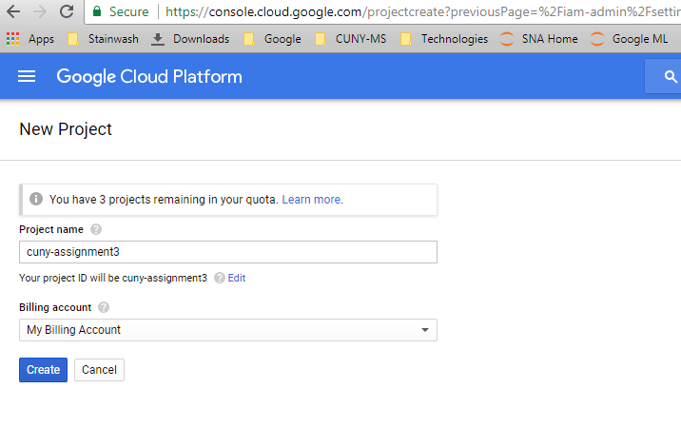

Step2: Create a compute engine and create a VM instance with name. I have selected a instance with 4vCPUs and 15 GM memory.

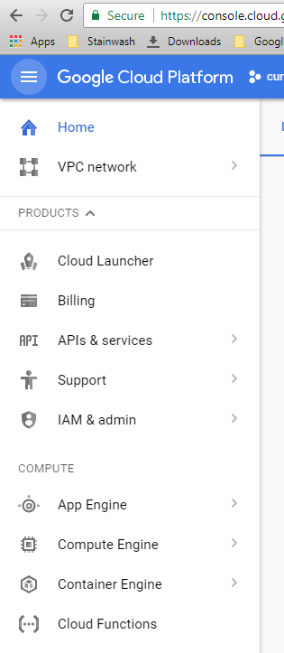

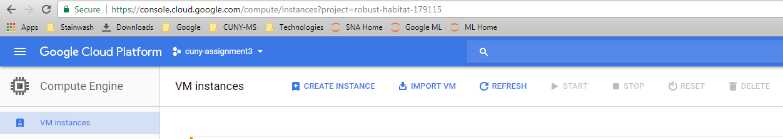

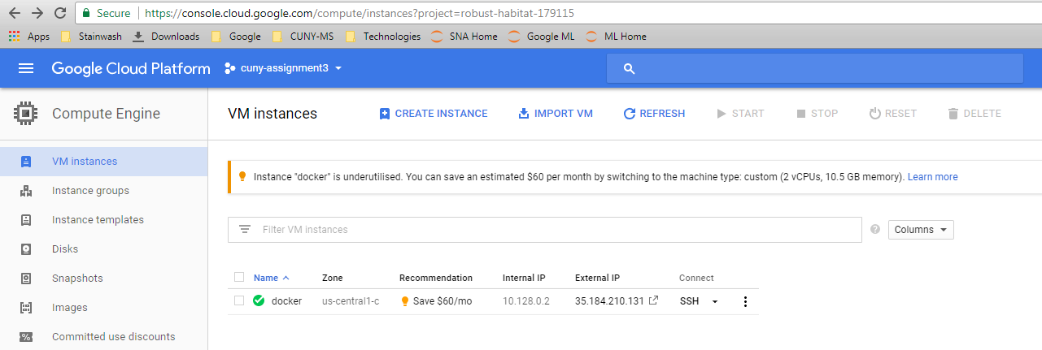

Step3: Connect to the instance via SSH in the browser. It automatically connects to the instance directly.

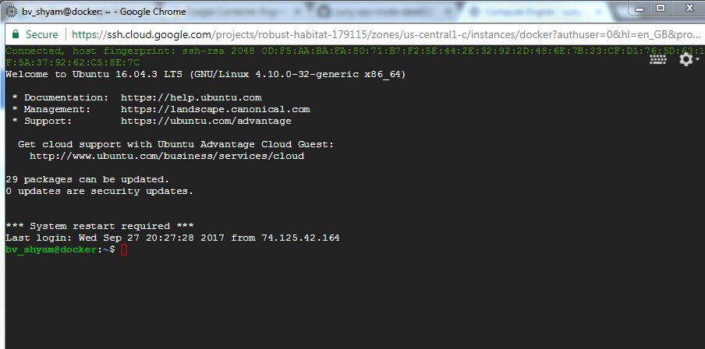

Step4: To update the packages and install docker in that instance. Once it is successfully installed, download the docker images which is required. I have built a custom image from a docker file which meets the needs.

This docker file has various packages included in it. Example, Keras, tensorflow and different analytics packages.

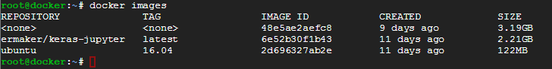

Step5: Once the required container is build, need to start the docker container with below command

sudo docker run -d -p 8888:8888 -v /home/notebooks:/home/ds/notebooks 48e

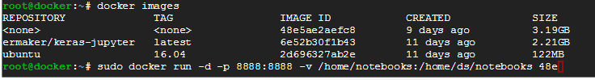

Step5: Install other required software’s like Git. Also download the Git repository to the docker container. After that install requirements.txt file from the project.

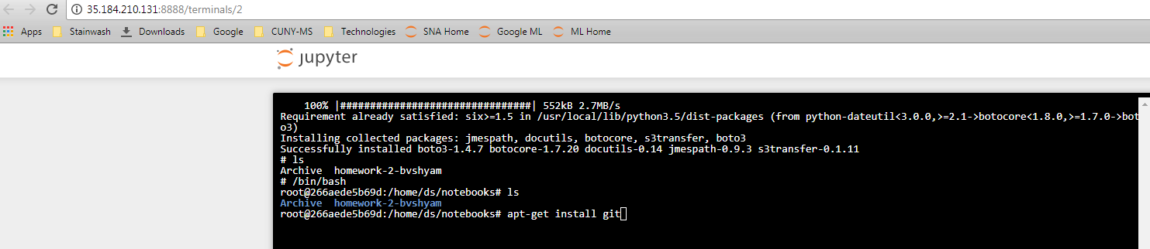

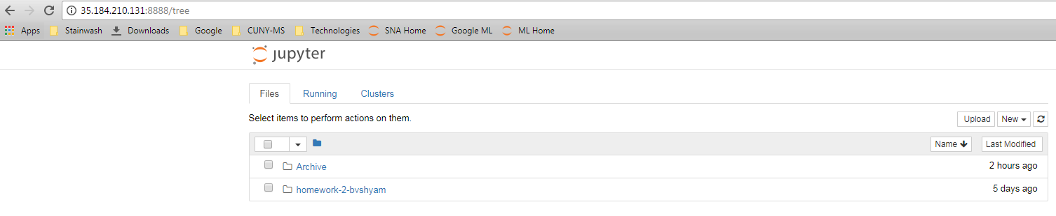

Step6: Open the python code and execute it. I converted it to ipython notebook and executed the files pull_data.ipynb, train_model.ipynb and score_model.ipynb.

